**Database Lab 2**

1)Select * from emp;

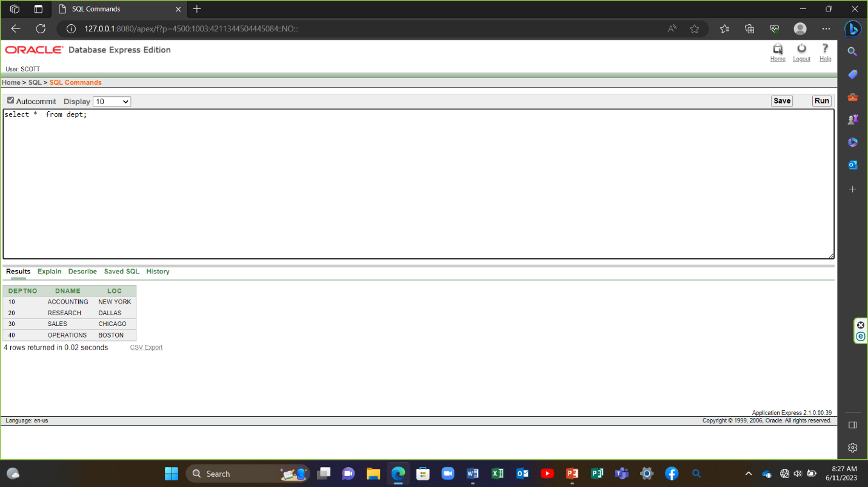

2) select deptno, loc from dept; 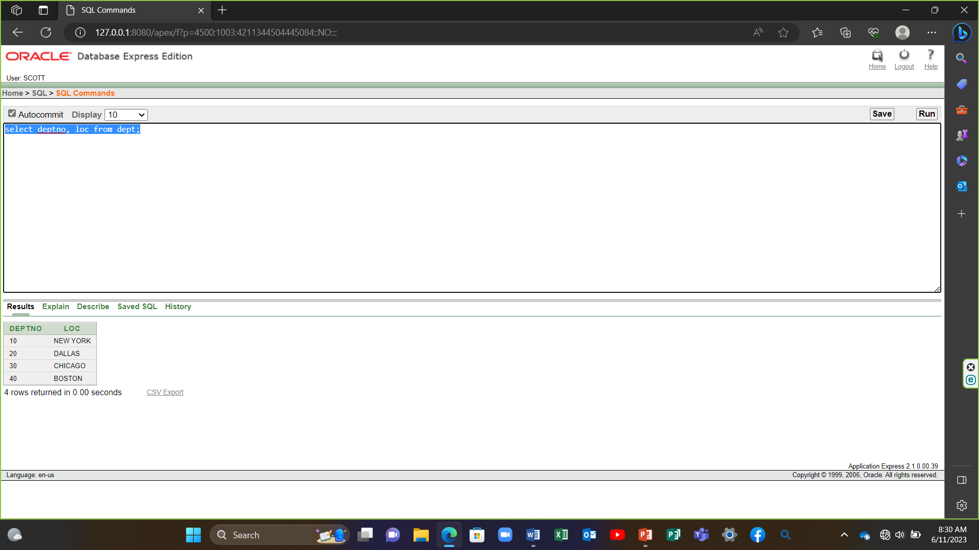

3) select ename,sal,sal+300 from emp;

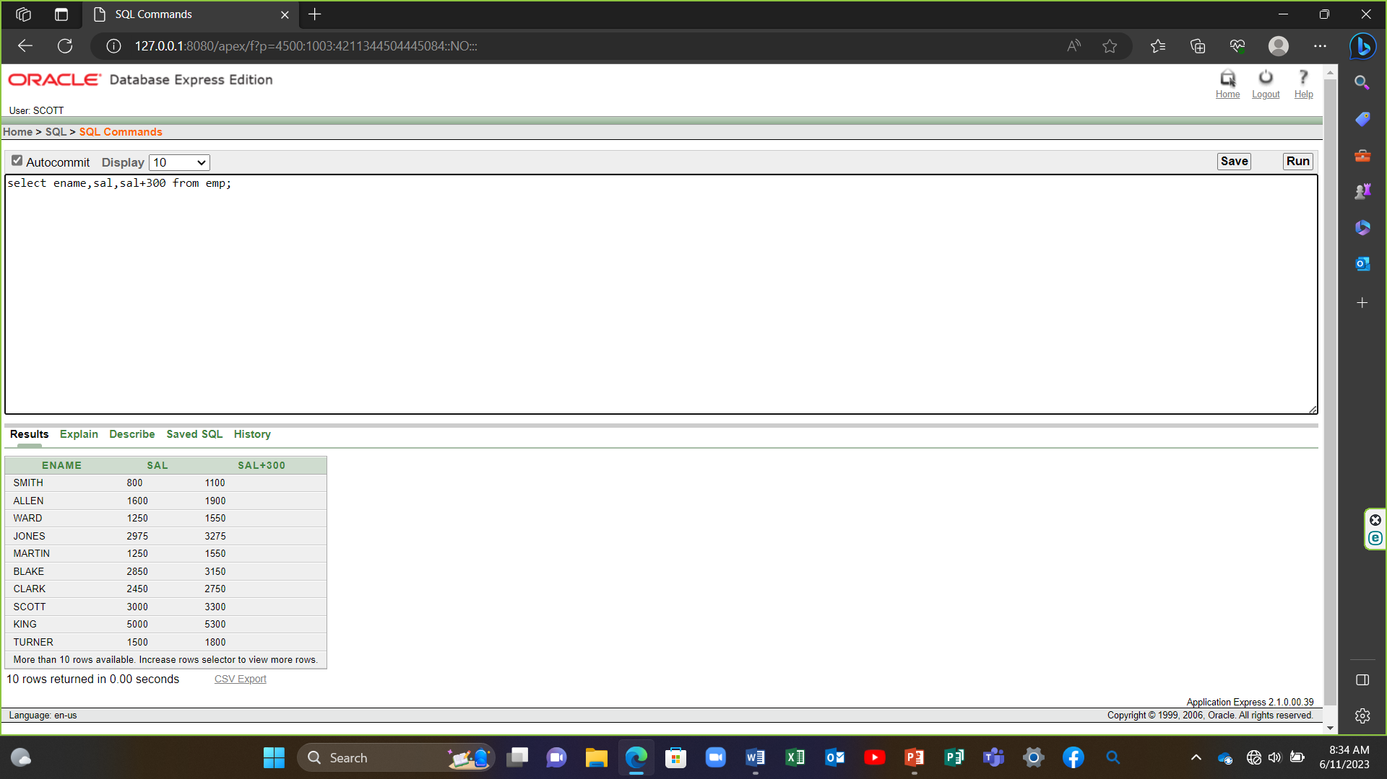

4) select ename,sal,12*sal+100 from emp;

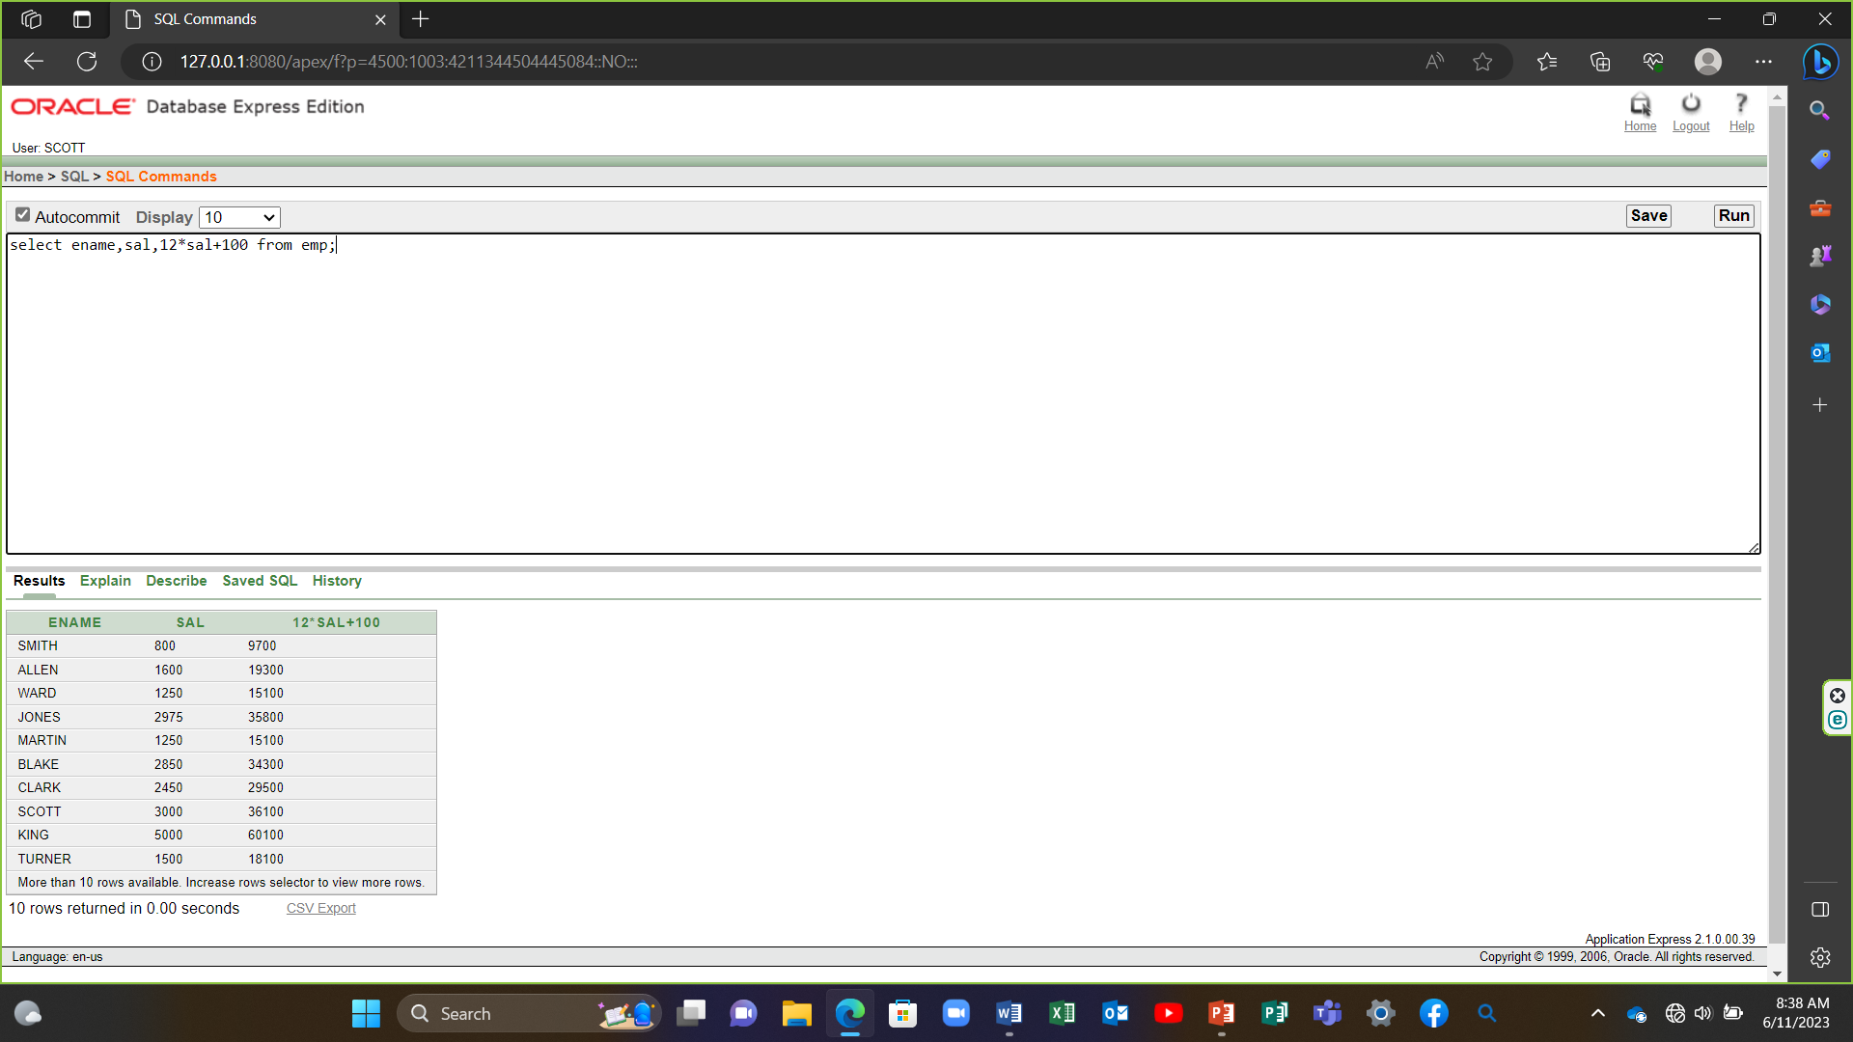

5) select ename,sal,12*(sal+100) from emp;

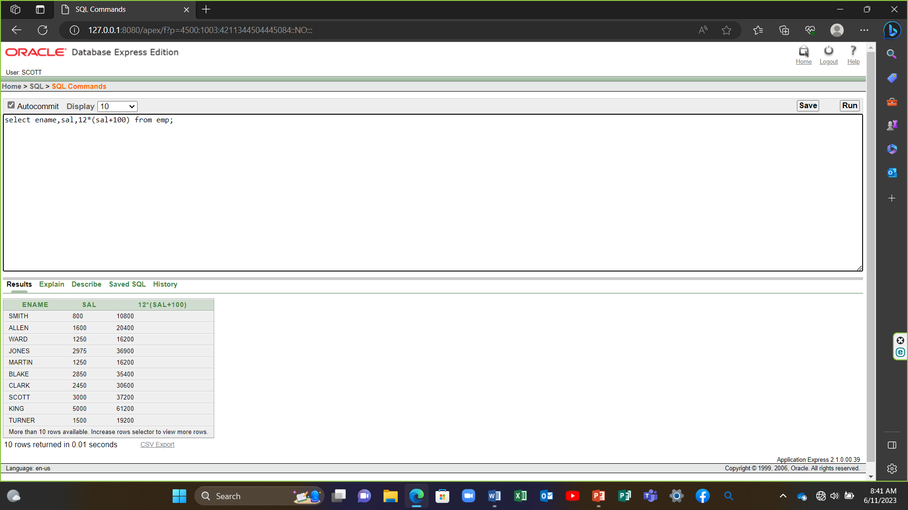

6) select ename,job,comm from emp;

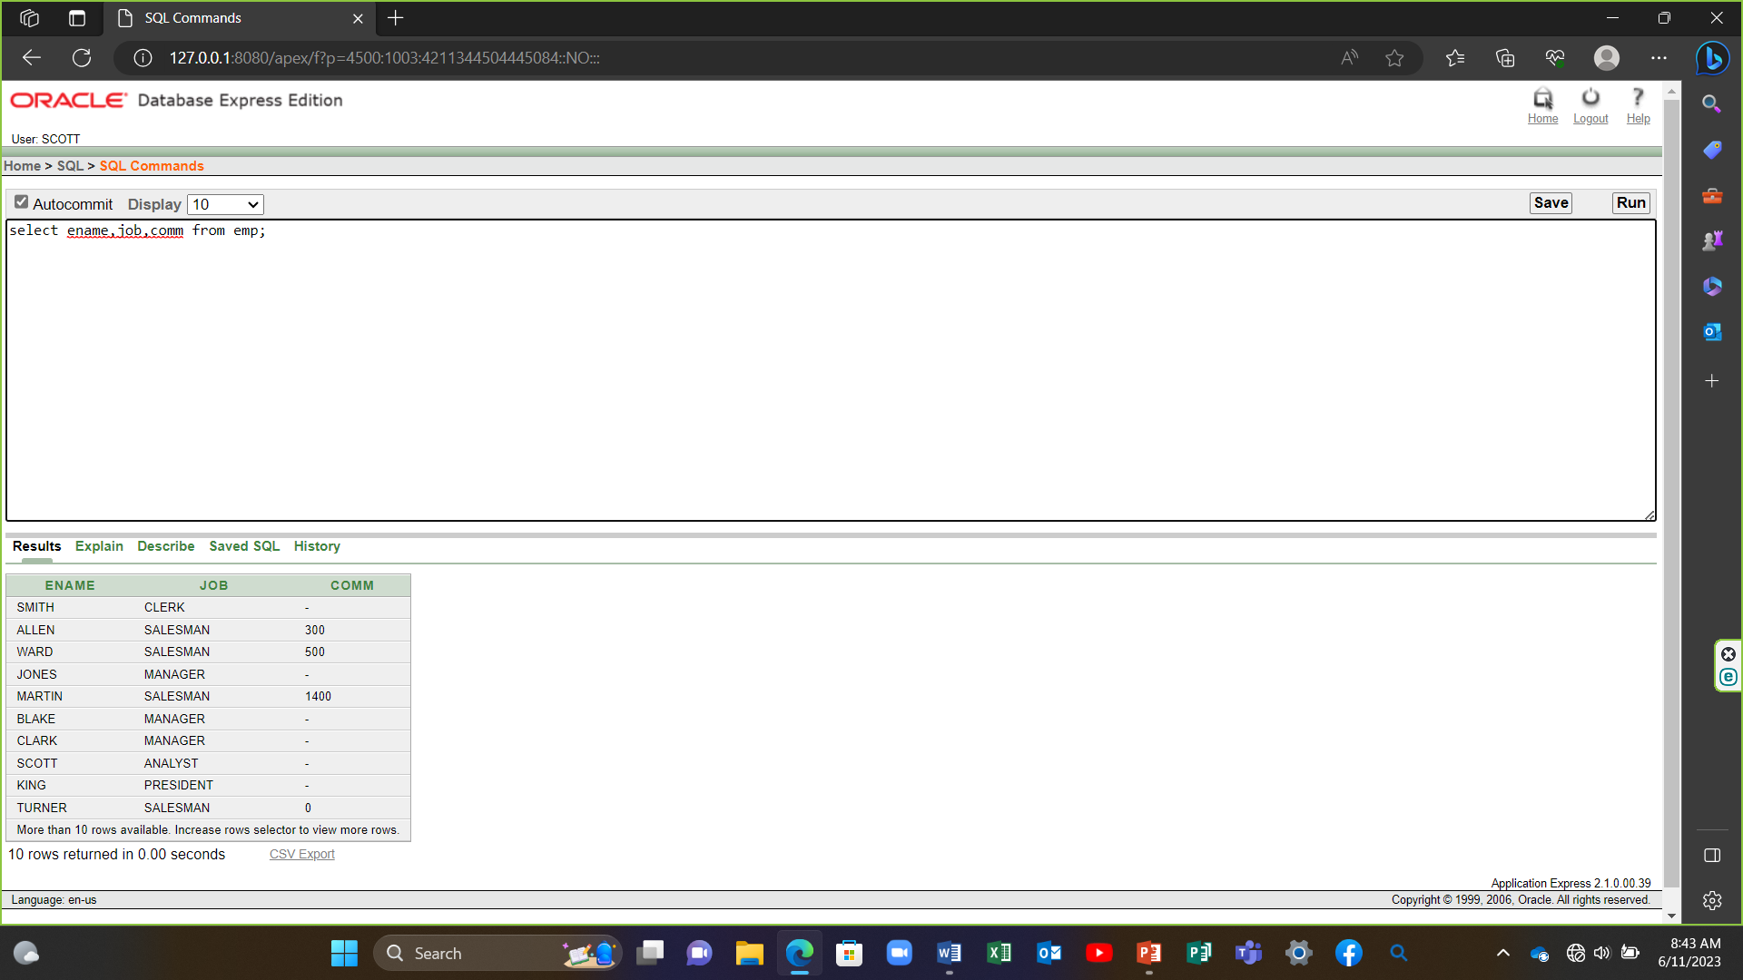

7) select ename,12*sal+comm from emp where ename= 'KING';

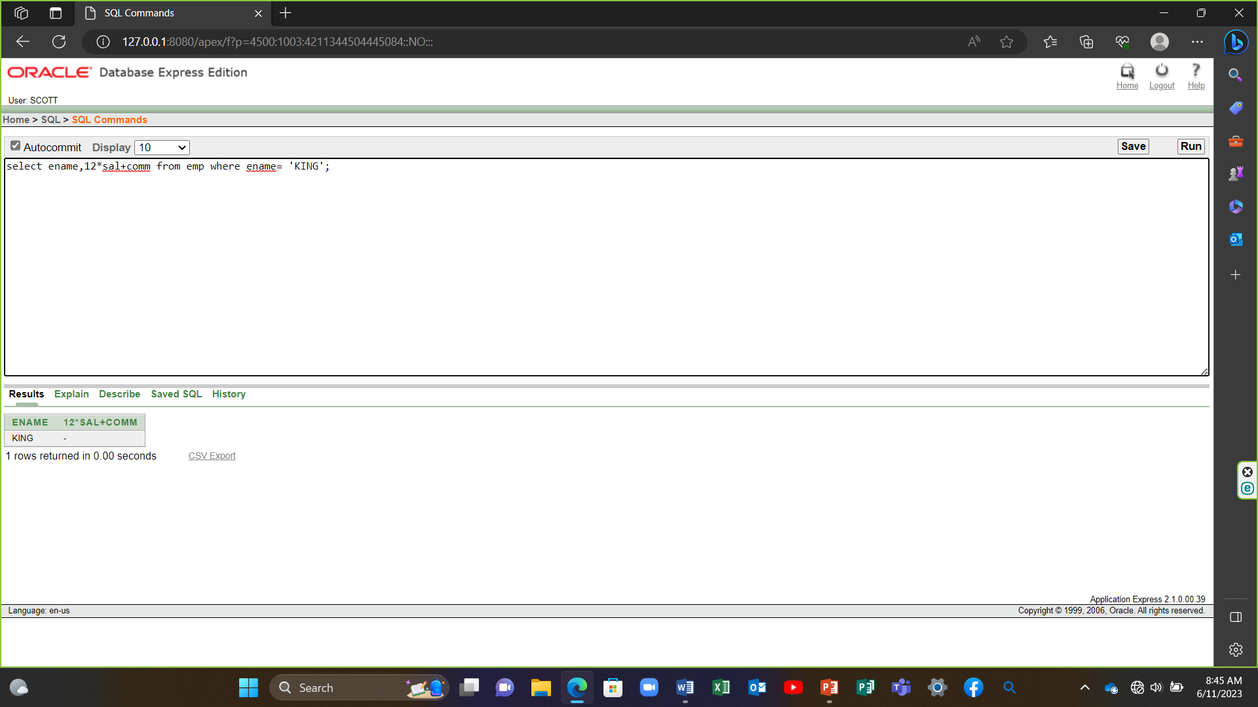

8) select ename as name,sal salary from emp;

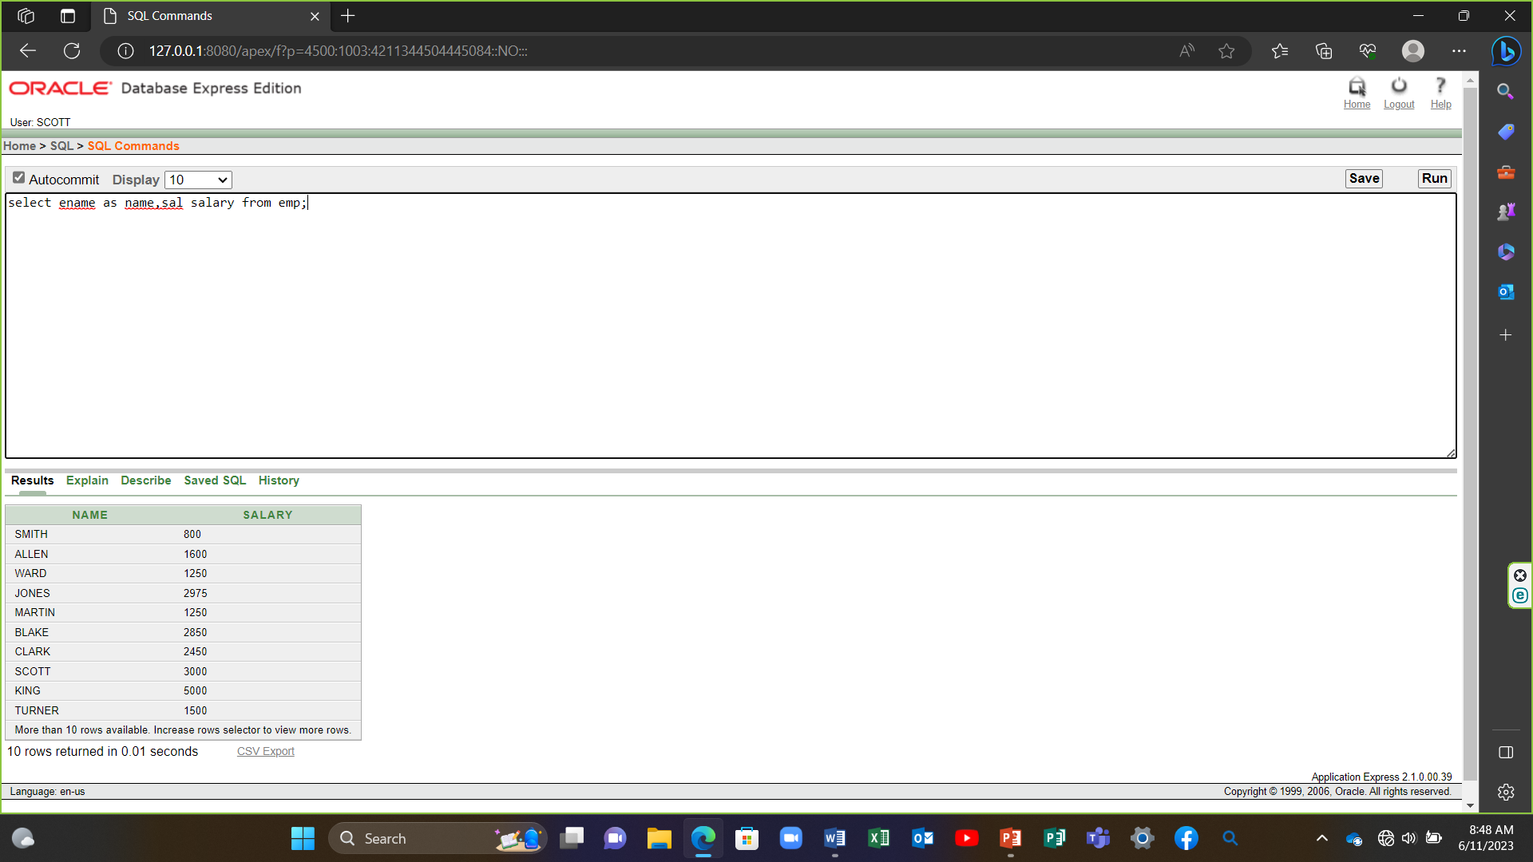

9) select ename "Name", sal*12 "Annual Salary" from emp;

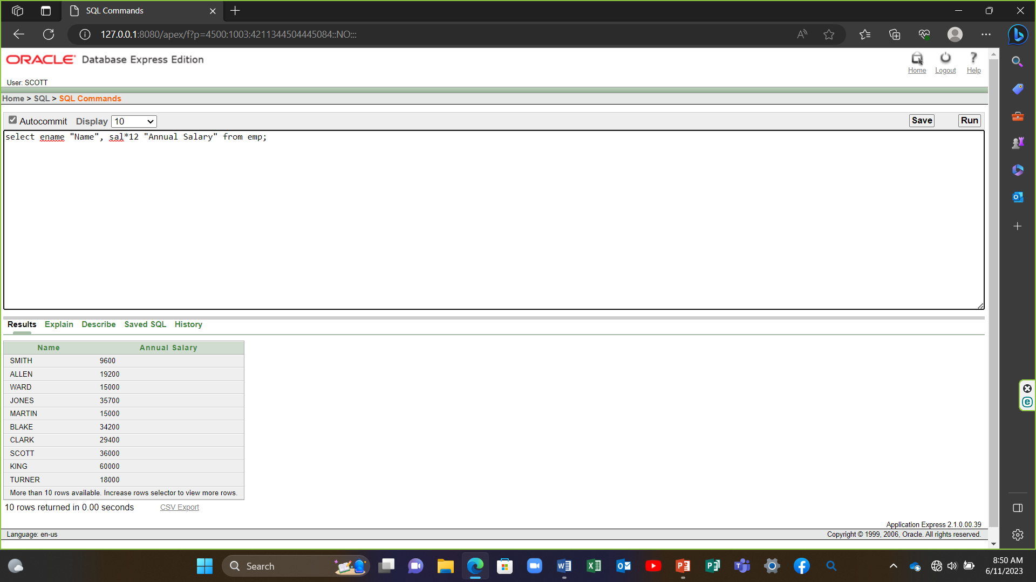

10) select ename || job as "Employee" from emp;

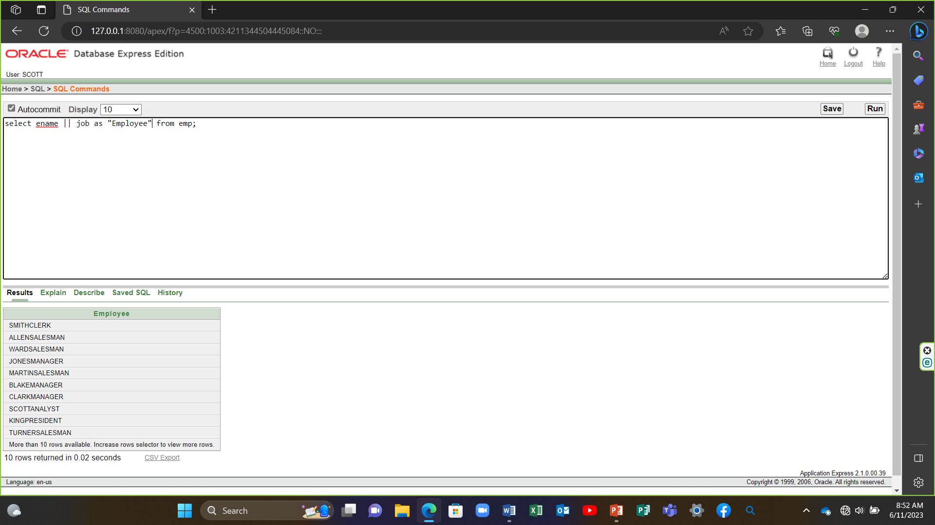

11) select ename ||' ' ||'is a'|| ' ' ||job as "Employee Details" from emp;

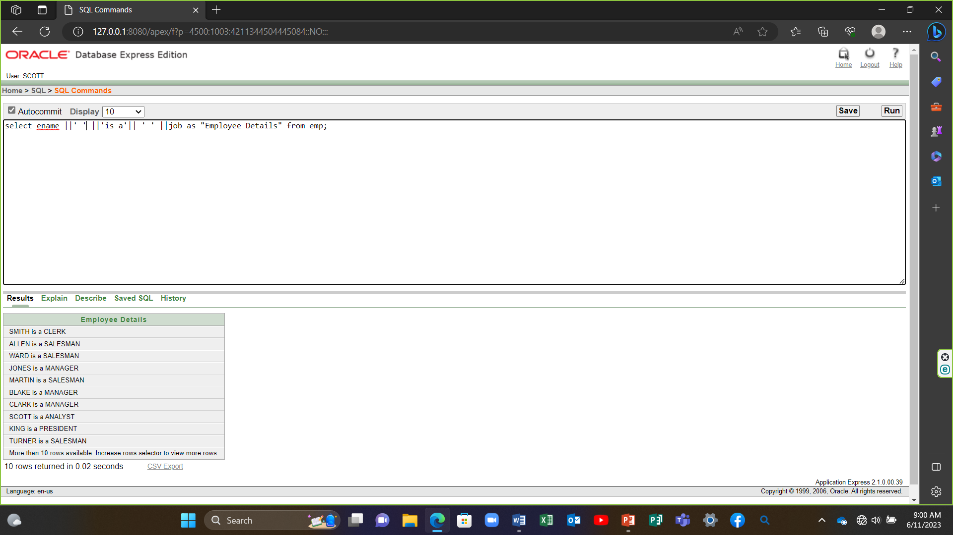

12) select deptno from emp;

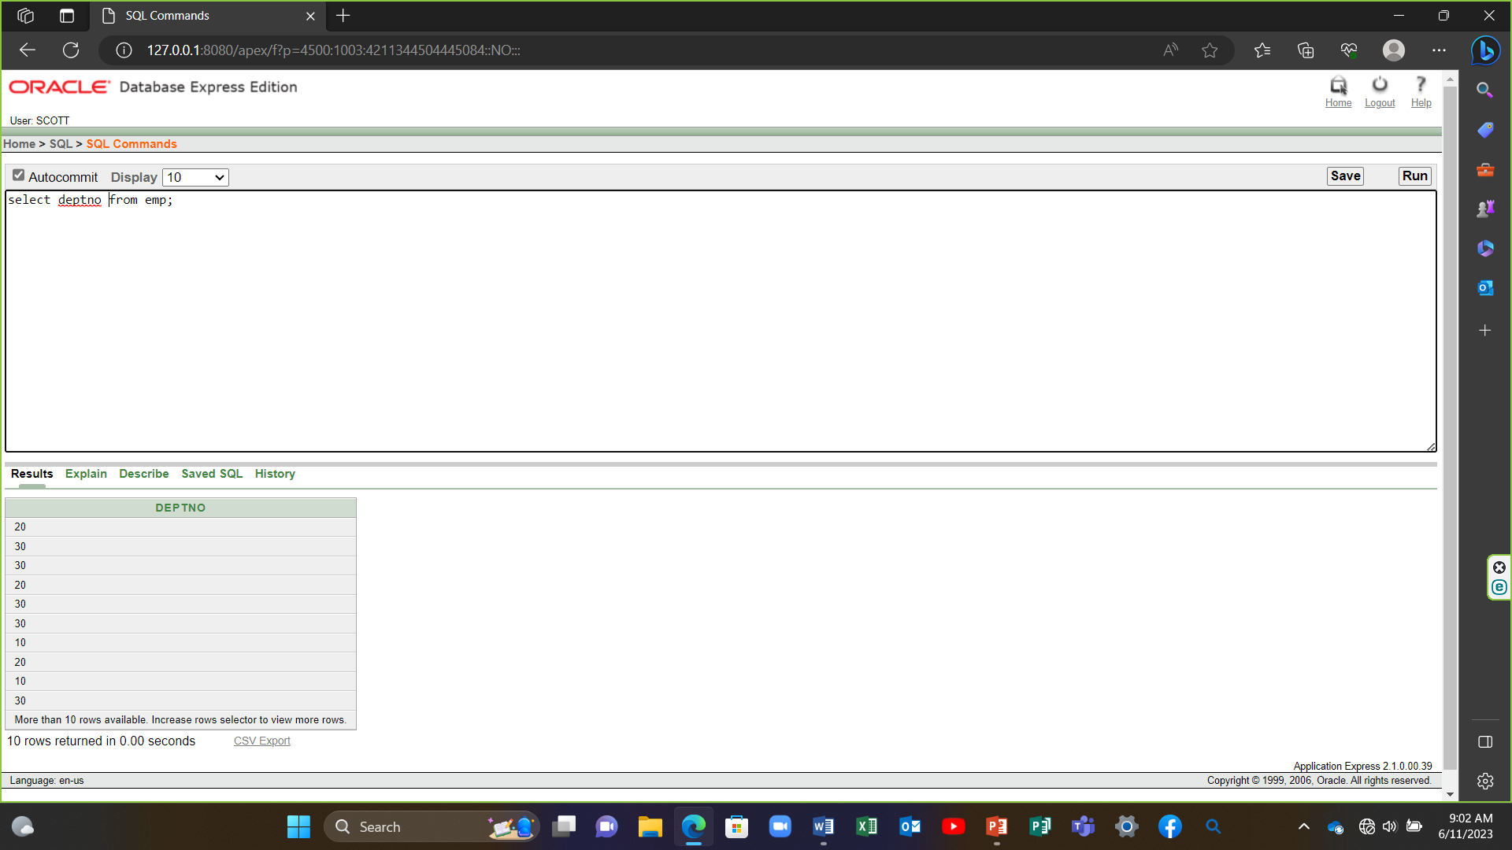

13) select distinct deptno from emp;

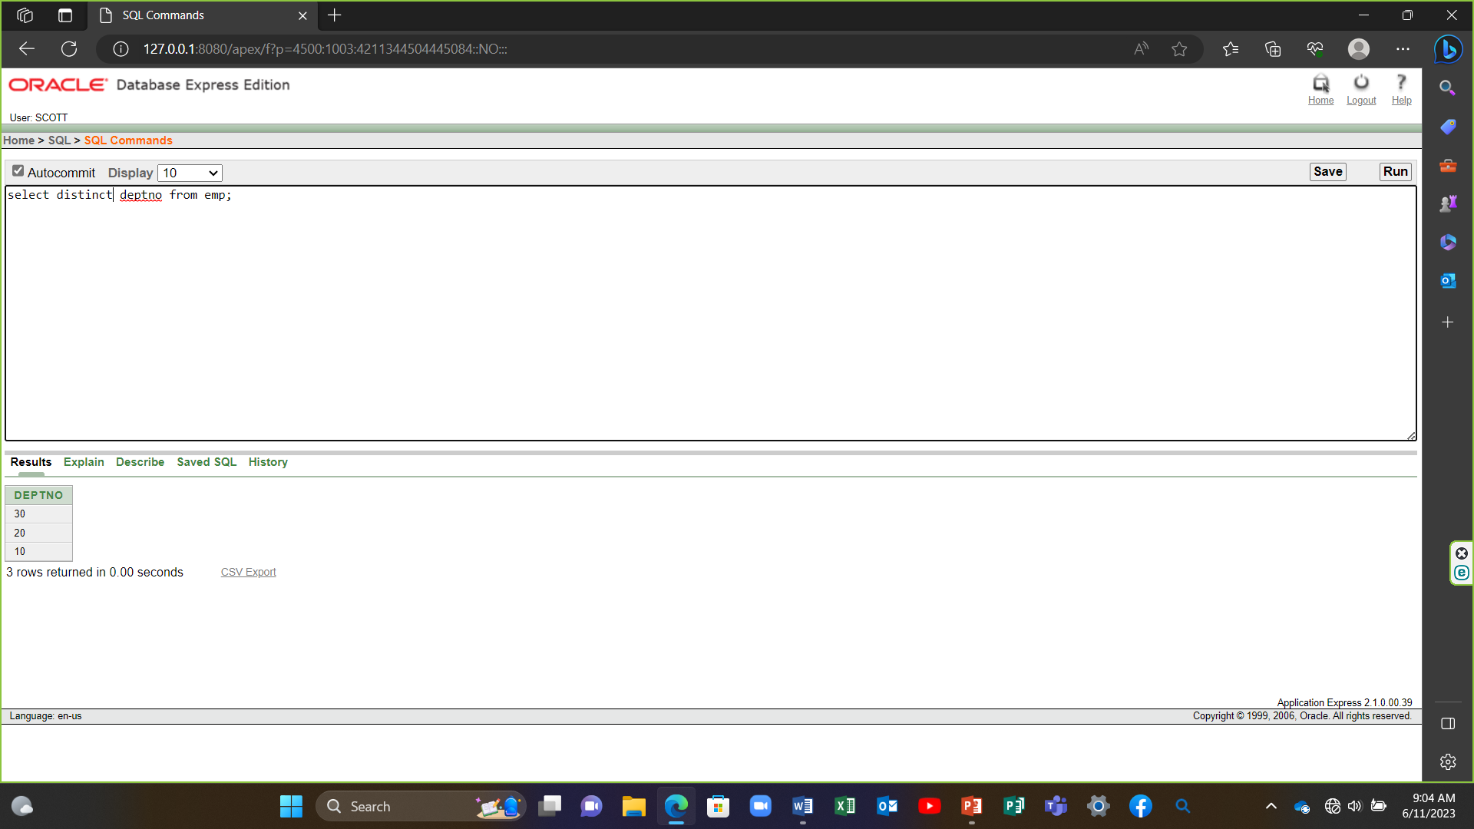

14) describe dept; 